(Approx. 996 words)

Renew the Artist in You: ArtRage 2
A Review by Rob Rice, a computer specialist living in Anchorage, Alaska and a member of the Computer Club of Oklahoma City
http://www.ccokc.org
articles(at)isp.com
Obtained from APCUG with the author's permission for publication by APCUG member groups.

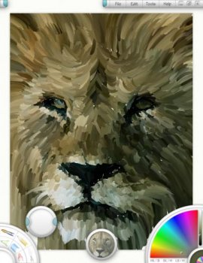
Spring is a season of light, color and renewal; it is a season that can bring out the artist in all of us. When I look at a product like ArtRage 2, by Ambient Design, I can feel some of that same renewal that spring offers right there on my computer screen. A clean, well behaved and very intuitive product, the free version of ArtRage 2 is about as difficult as finger painting.

Coded in the low stress environment of a New Zealand forest, just outside of Auckland, ArtRage is a nice blend of a simple user interface with the power to create high quality work. I say that ArtRage is about as difficult as finger painting and I mean that, but do not think that it shares finger painting’s limitations. One look at some of those samples on this page (From the Ambient Design website) should be obvious.

Since its initial release by former MetaCreations Corporation employees Andy Bearsley and Matt Fox-Wilson in 2004 as a free product, ArtRage has been steadily polished and improved. Available in English, French and German versions, for both Windows and MacOSX, a new edition for the UltraMobile PC is also available.

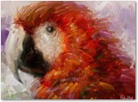
A recipient of many awards, ArtRage comes with a good user’s manual and several helpful tutorials are available on the Ambient Design website, such as how to paint a Macaw.

Installing and opening ArtRage 2 offers no surprises, such as ads, spyware, or pressure to buy the full version. You are greeted with a clean interface. On the lower left is your Tool Picker which contains:
- Oil Brush.
- Pencil.
- Palette Knife.
- Eyedropper.
- Felt Pen.
- Chalk.
- Crayon.
- Eraser
More tools are added in the full version such as Airbrush, Paint Tube, Glitter, and Paint Roller.
On the lower right is the Color Picker. At top is a menu containing such familiar options as File, Edit, Tools, and Help.
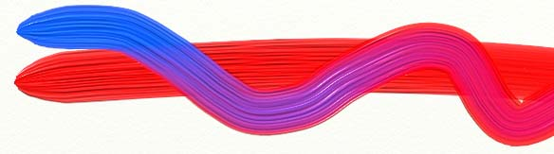
Various other menus are located at the sides which allow for brush pressure and tilt angle. One of my favorite features is the Tracing Images and References feature. With Tracing Image the original is projected on to your canvas so that you can use it as a guide while you sketch and paint. Other features include (From the Ambient Design website):
- Layers: Paint on transparent layers to build up more complex images without the paint blending with your underlying work. The texture of the underlying paint will still show through, as if it were dry on your canvas. ArtRage also provides full support for all 23 Photoshop layer blend modes.
- PSD Support: Import and export PSD files, with their layers intact.
- Custom Colours: Load and save custom colour set and colour pickers to fine tune your colour work.
- Crop & Resize: Crop and resize your paintings during work.
- Simple, Intuitive Interface: The ArtRage interface is easy to understand and doesn’t get in the way of your work. In fact, it even gets out of the way while you’re painting...
- Customizable Canvases: Change the grain, colour, and even metallic nature of your canvas at any time during your work.
- Canvas Positioning: Move, Scale, and Rotate the canvas to your preferred angle.
- Tablet Support: ArtRage uses your tablet’s pressure and tilt support where available.
- Tool Cursors: Every tool has a cursor that tells you exactly how big the tool head is, to make it easier to see what’s going to be applied.
- Multi-Monitor Support: ArtRage supports multi-monitor systems.
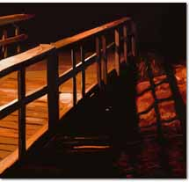
It appears that every effort has been made to make the painting and drawing as realistically as possible - even down to providing a water glass to clean your brush in!
Paints blend predictably or not at all, your choice. Textures, blending and smudging all appear extremely accurate.
As I mentioned earlier, there is a Full version which sells for $19.95. It unlocks several features such as the Metallic Paint option; with this feature enabled you can paint with gold and silver oil paints, sparkling glitter, silver leaf sprays and more. Tools can be switched to Metallic mode for a range of effects.
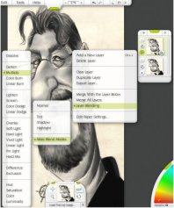
Checking with the forums to see what users were saying about the product, a common topic was how, after using the free version of ArtRage, they bought the full version and never looked back. After playing with the free edition, I can see why. ArtRage 2, is a terrific program and worth the money. ArtRage 2 is rare combination of a program that can do high quality work and yet make the computer fun again!
Windows: Windows XP, 2k, or Tablet PC. 800 MHz processor or faster and 256 megabytes of RAM.
Macintosh: Macintosh OS X 10.3.9 or later. G4 processor or faster and 256 megabytes of RAM. ArtRage for OS X is a universal binary.
Ambient Design, http://www.ambientdesign.com/
ArtRage 2 at Ambient Design, http://www.ambientdesign.com/artrage.html
ArtRage 2 Quick Start Guide, http://www2.ambientdesign.com/files/quickstart.zip
This article has been provided to APCUG by the author solely for publication by APCUG member groups. All other uses require the permission of the author (see e-mail address above).
NOTE from Judy: I thought I’d ask if we could have a discount for this program and Ambient was gracious enough to offer UG members a 15% discount ($19.95 MSRP) on the program for either Windows or Mac OSX. The code is valid until July 20th.

The code is: 0B6D7A19D

When a potential customer uses the online store
(http://store.kagi.com/cgi-bin/store.cgi?storeID=6FCJJ_LIVE&&), they enter the platform they'd like to purchase ArtRage for (Windows or Mac OSX) and when they view their cart to enter payment details, there is a Coupon/Promotional Code entry box in which that coupon ID can be entered.

